Parish Clerk | 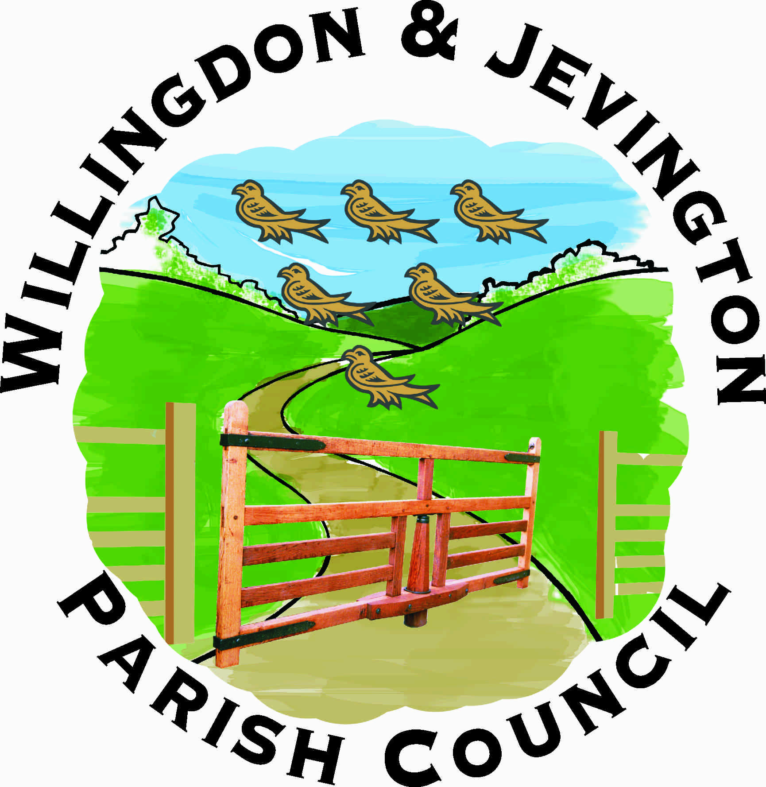 | Office Hours 9 am to 1 pm
The Parish Office, The Triangle |  | Monday to Friday
Willingdon
East Sussex BN20 9PJ |  | Telephone: 01323 489603
www.willingdonandjevington.org.uk |  | email: parishclerkwjpc@btconnect.com

Terms of Reference for Events Committee

Appointed by | Full Council
Number of Members | Unlimited
Membership Renewed | Annually
Minimum number of meetings | 4 per annum
Delegated authority for decisions | Yes
Delegated authority for own budget | Yes
Can appoint Sub-Committee | Yes

Areas of responsibility
- To agree and arrange a program of events for the benefit of residents of Willingdon and Jevington, including but not exclusive to Music in the Park, Willingdon and Jevington in Bloom, Christmas Carol Evening, Public Information Day and Remembrance Sunday Parade.
- To assess and budget for events for which it is responsible, and obtain sponsorship where possible.
- To agree which charity/charities to support with the proceeds of Music in the Park.
- To ensure necessary risk assessments are completed and any required permissions, event licenses or other agreements are obtained prior to any event.
- To agree publicity for each event, including promotional material and any press releases prior to or post the event.
- To agree the rules and procedures for any competition run as part of an event.
- To prepare an annual budget for recommendation to Finance and General Purposes Committee.

