Parish Clerk | 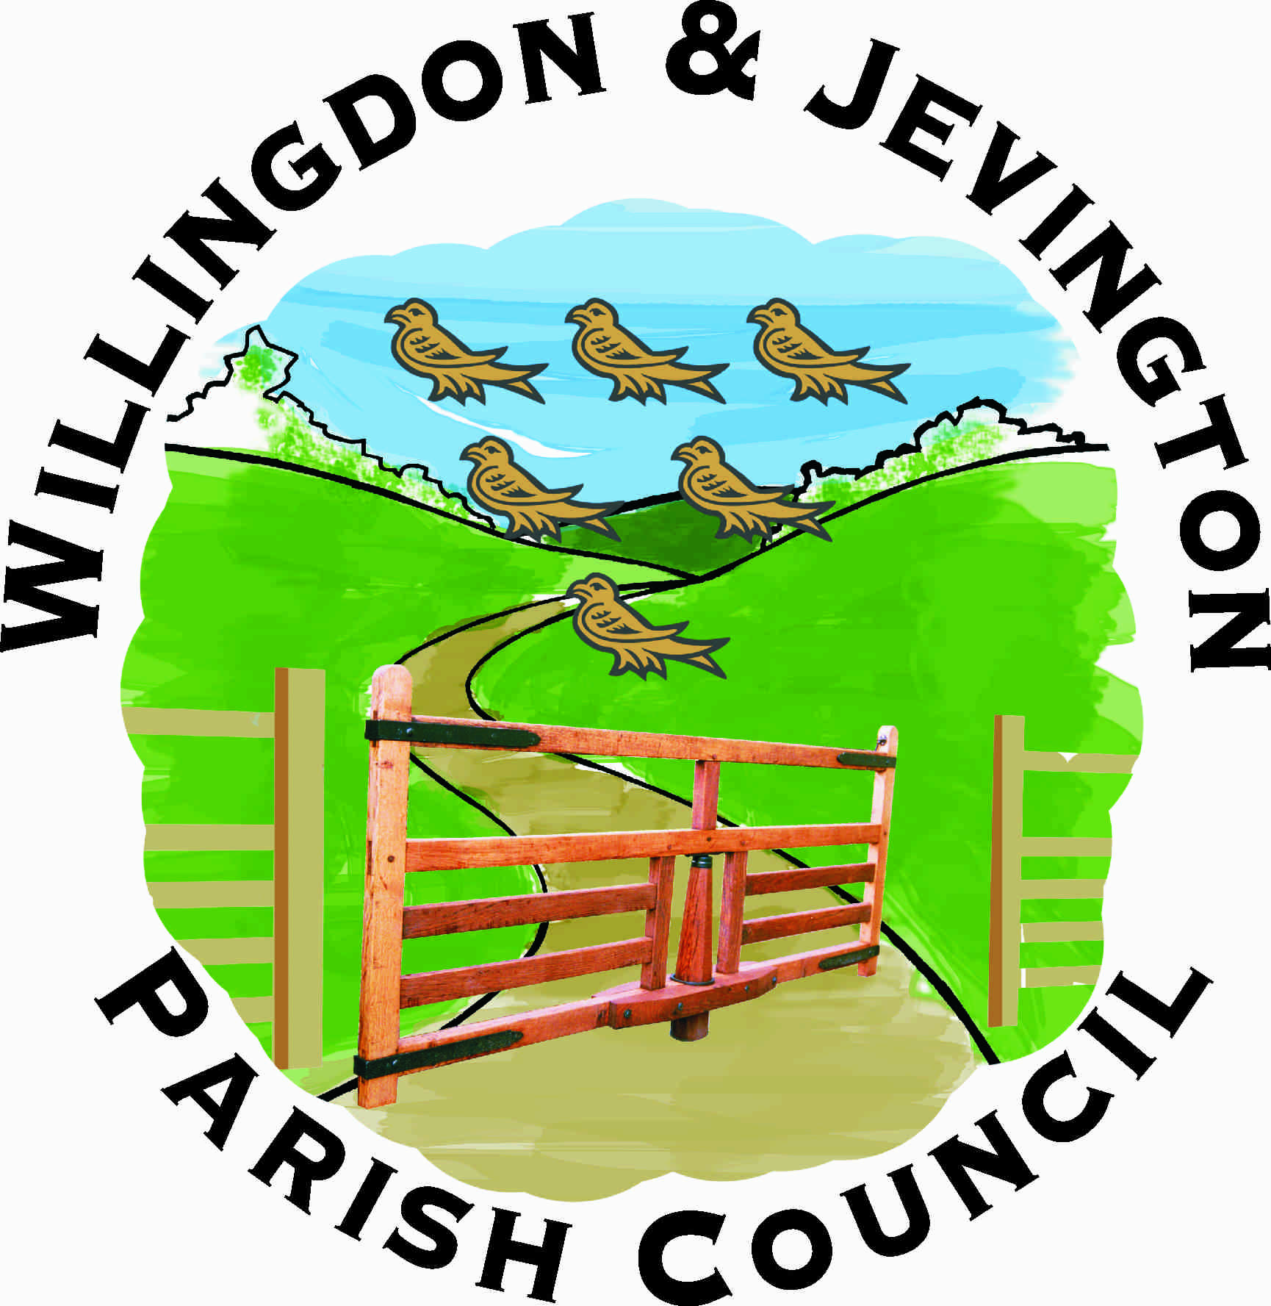 | Office Hours 9 am to 1 pm
3 Gorringe Valley Road |  | Monday to Friday
Willingdon
East Sussex BN20 9SX |  | Telephone / Fax: 01323 489603
www.willingdonandjevington.org.uk |  | email: parishclerkwjpc@btconnect.com

Terms of Reference for Planning and Licensing Committee

Appointed by | Full Council
Number of Members | Unlimited
Membership Renewed | Annually
Minimum number of meetings | 12 per annum
Delegated authority for decisions | Yes
Delegated authority for own budget | No
Can appoint Sub-Committee | Yes

Areas of responsibility
- To provide responses to Wealden District Council, South Downs National Park Authority or East Sussex County Council on any matter relating to planning applications or development control.
- To encompass all areas pertaining to planning matters which affect Willingdon and Jevington Parish Council including planning contraventions, enforcement, conservation areas and tree preservation orders.
- To represent the Parish Council in Planning or licensing matters at any site meeting, panel hearing or other meeting called by Wealden District Council, South Downs National Park Authority or East Sussex County Council.
- To be responsible for the formation of any Neighbourhood plan.

