Parish Clerk | 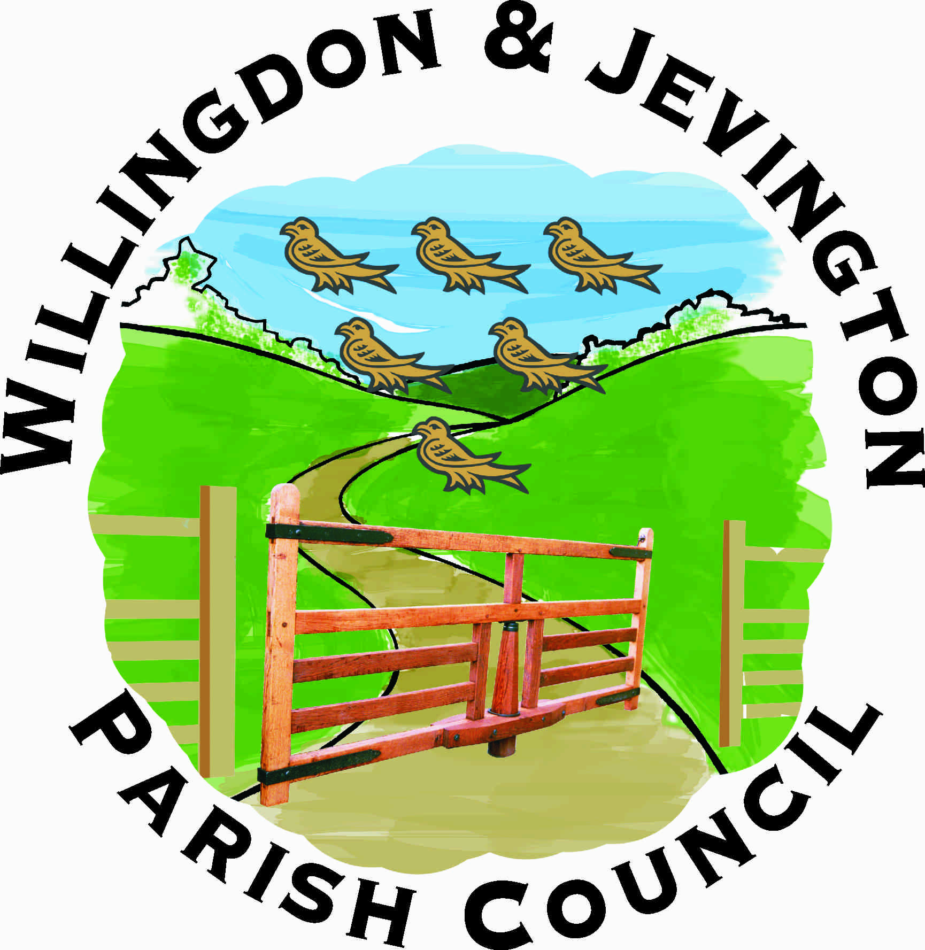 | Office Hours 9 am to 1 pm
3 Gorringe Valley Road |  | Monday to Friday
Willingdon
East Sussex BN20 9SX |  | Telephone / Fax: 01323 489603
www.willingdonandjevington.org.uk |  | email: parishclerkwjpc@btconnect.com

Terms of Reference for SLR Sub-Committee

Appointed by | Finance & Policy Committee
Number of Members | Unlimited
Membership Renewed | Annually
Minimum number of meetings | 4 per annum
Delegated authority for decisions | No
Delegated authority for own budget | No
Can appoint Sub-Committee | No

Areas of responsibility
- To represent the Parish Council’s interests in relation to works carried out under the jurisdiction of East Sussex County Council.
- To bring to the attention of East Sussex County Council areas of concern affecting the Parish.

